Chuẩn bị

1. Tải netbean

<https://archive.apache.org/dist/netbeans/netbeans-installers/22/Apache-NetBeans-22-bin-windows-x64.exe>

* 1. java 20

1. SQL server 2020 bản developer

https://go.microsoft.com/fwlink/p/?linkid=2215158&clcid=0x409&culture=en-us&country=us

1. Visual Studio 2022
   1. Tải thư viện giống hình dưới nhé

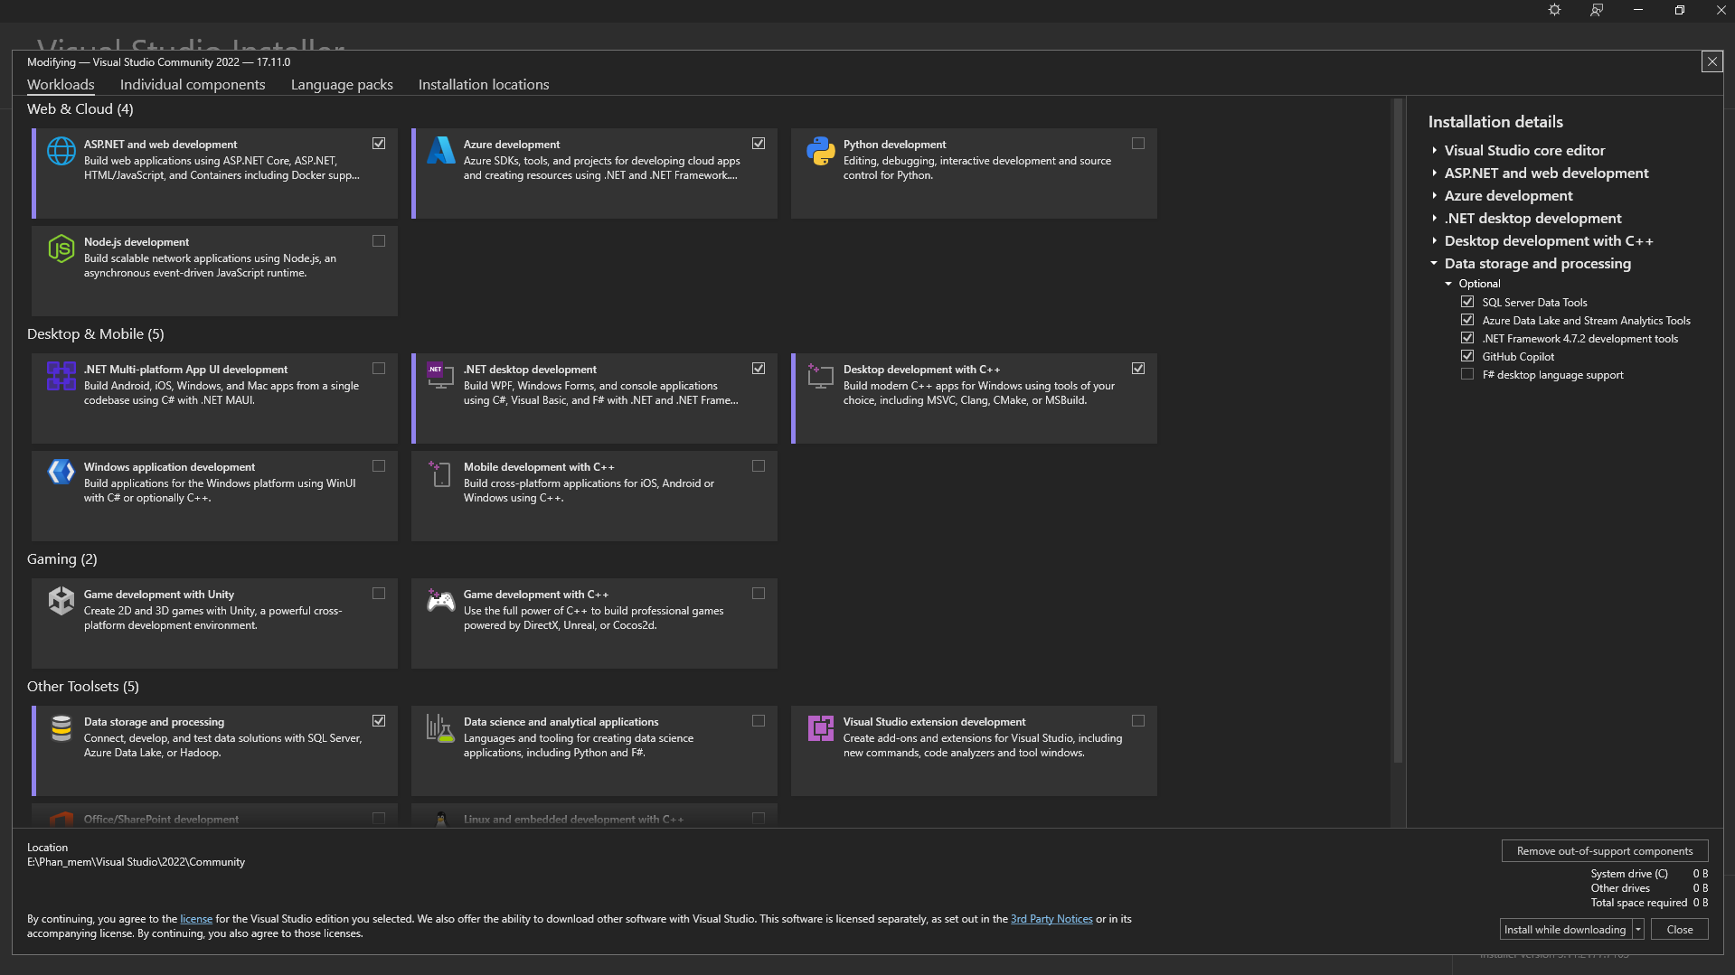

* 1. Extensions trong vs code

C#

C# Dev Kit

.NET Extension Pack

.NET Install Tool

Nuget Gallery

Prettier

Extension Pack By JosKreativ